Name: Sathwik S Hegde
USN: 4MT19CS138

SNIFFING USING WIRESHARK
Wireshark is a popular network protocol analyser that allows you to capture, view, and analyse network traffic in real-time. It is an open-source software tool that can be used to troubleshoot network issues, identify security vulnerabilities, and analyse network performance.

Step 1: Login to kali as root user and type Wireshark.
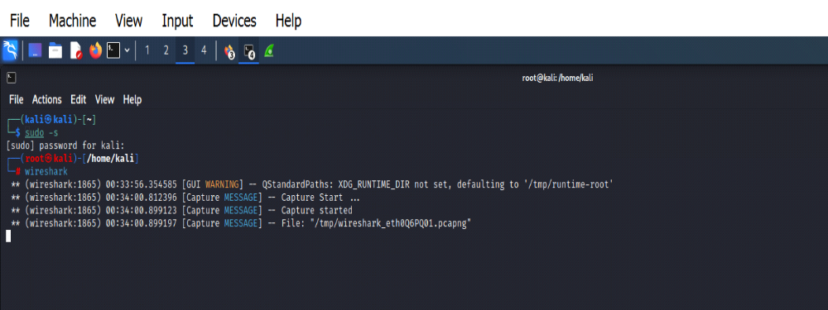

Step 2: Wireshark Network Analyzer will be opened and double click on eth0(1st option).

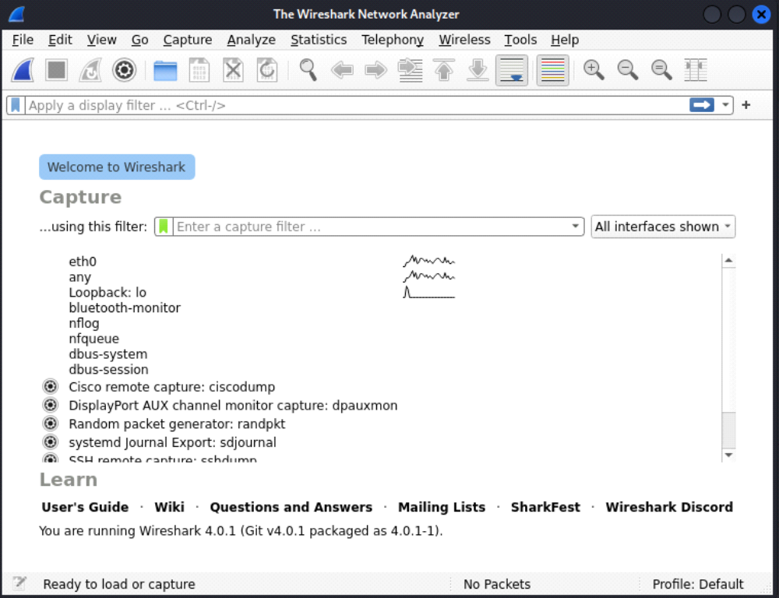

Step 3: Go to Firefox and search testfire.net

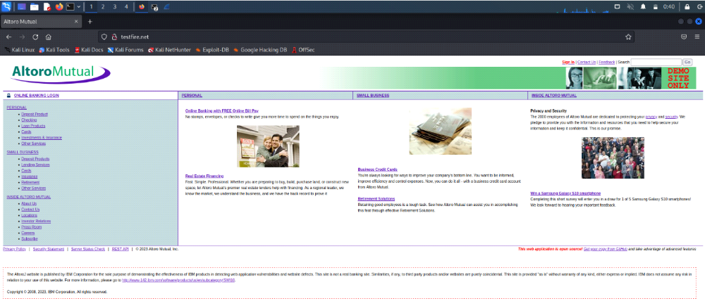

Username: admin Password: admin
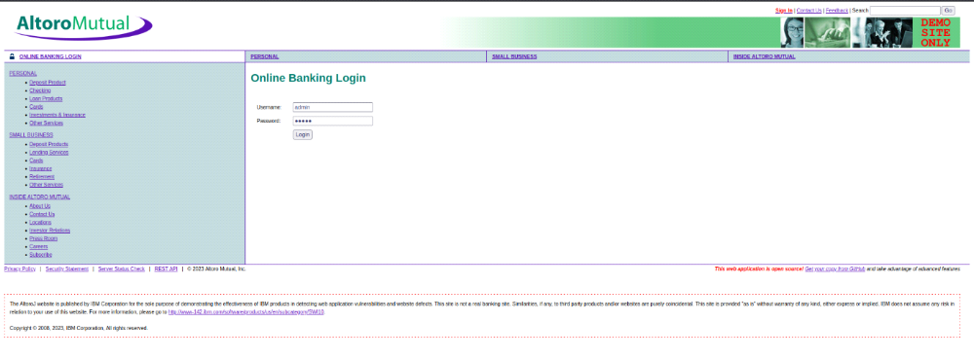
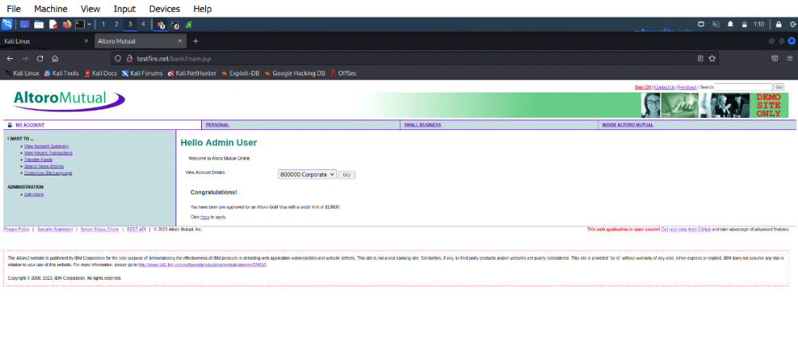
Step 4: Go to wire shark and in search bar filter http -post. By clicking last option, you will get the password and username we able to crack it.
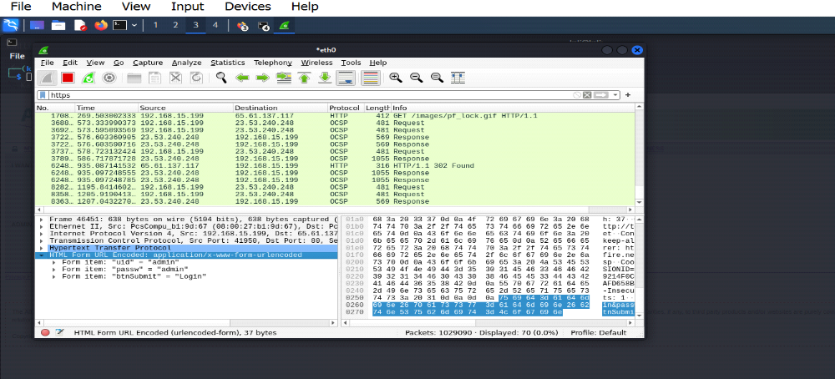

SNIFFING WITH ETTERCAP

Ettercap is an open-source tool that can be used to support man-in-the-middle attacks on networks. Ettercap can capture packets and then write them back onto the network. Ettercap enables the diversion and alteration of data virtually in real-time.
Step 1: To perform Ettercap turn on Meta, Windows7 and Kali-Linux.
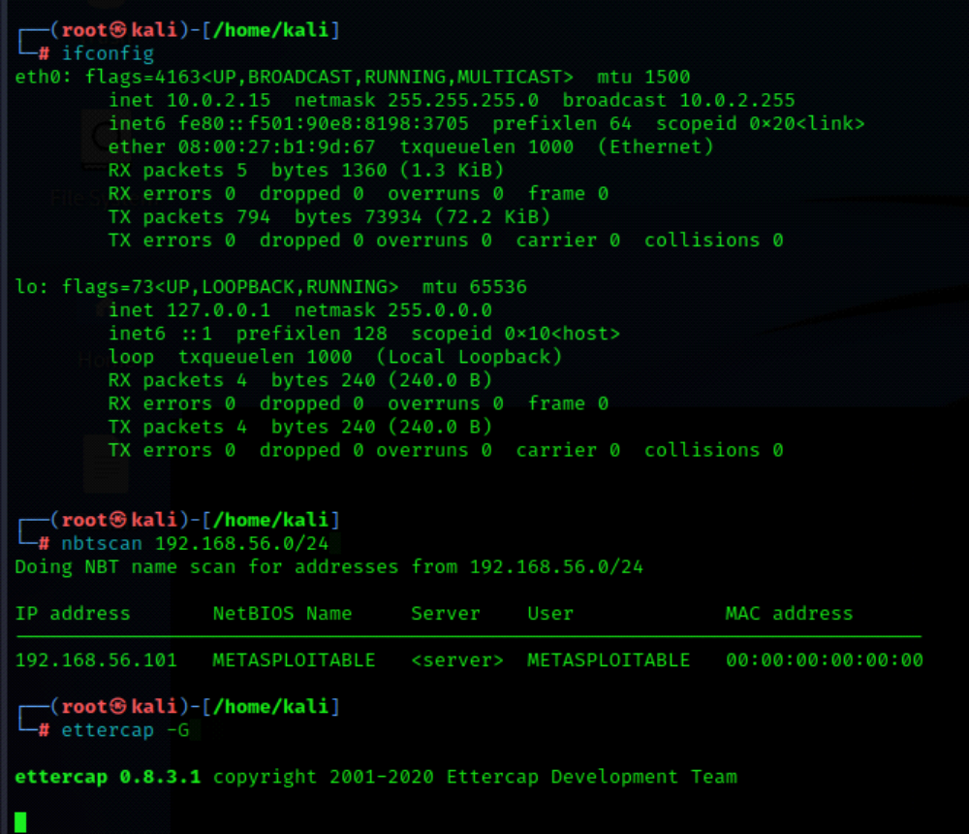

A pop-up window appears on the screen and now click the  mark.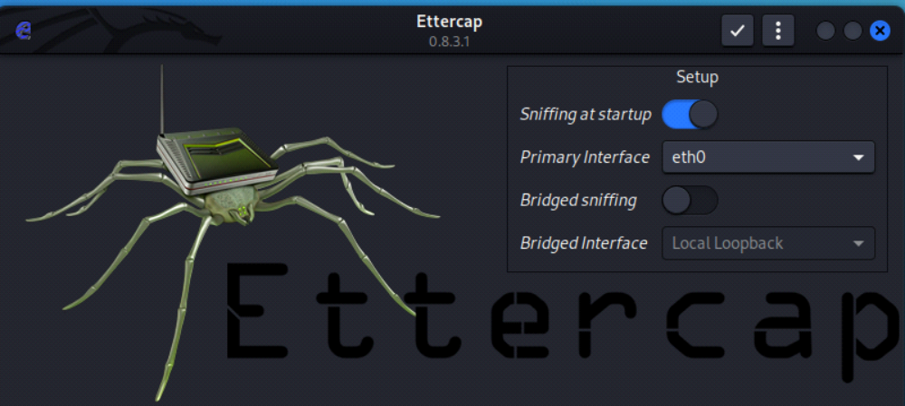
Step 3: Select three dots in the top right corner then select hosts -> scan for the hosts from the page displayed below.
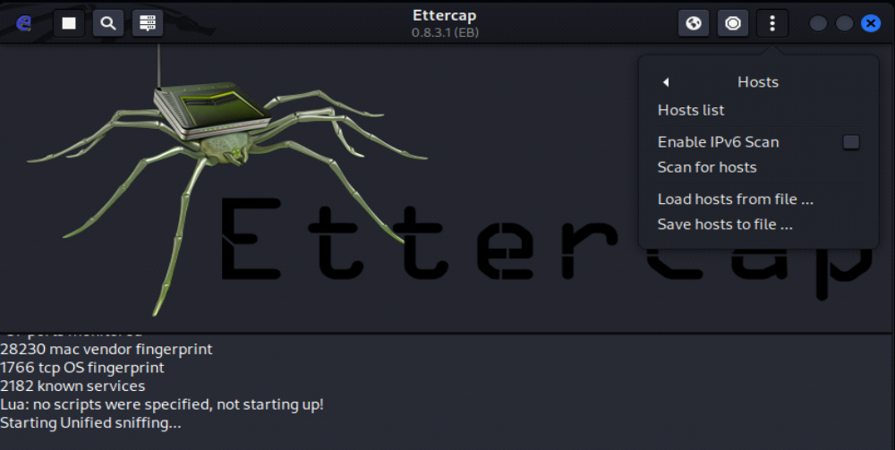
Then again select 3 dots -> hosts -> hostlists and the below window will display
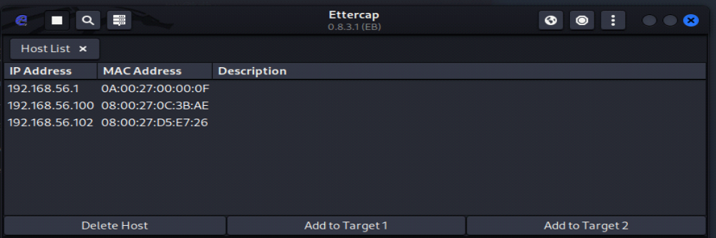
Select the IP of windows7 [192.168.56.103] and add to target1 and select IP network of Metasploitable [192.168.56.101] and add to target2.
Step 4: Select ARP poisoning from the drop-down menu on clicking globe icon. In ARP poisoning attacker sends falsified ARP messages over a LAN to link an attacker’s MAC address with the IP address of a legitimate computer or server on the network.
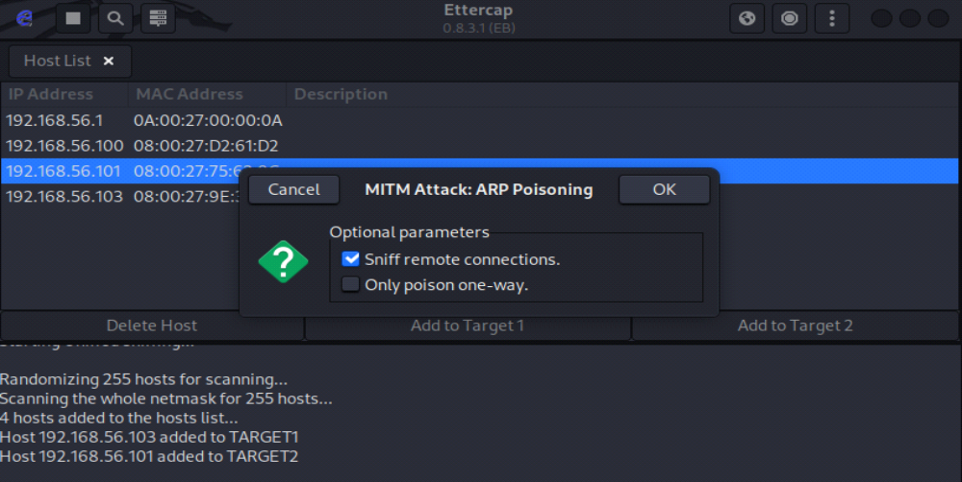
Step 5: Open firefox in the windows 7 and browse the IP address of metasploitable machine and select DVWA option and enter the username and password to login.
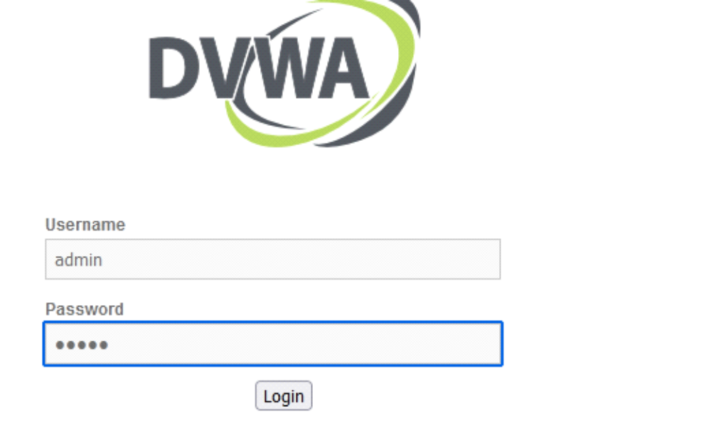

Step 6: Transfer packets from metasploitable machine to windows 7.
[command: ping windowsIP]
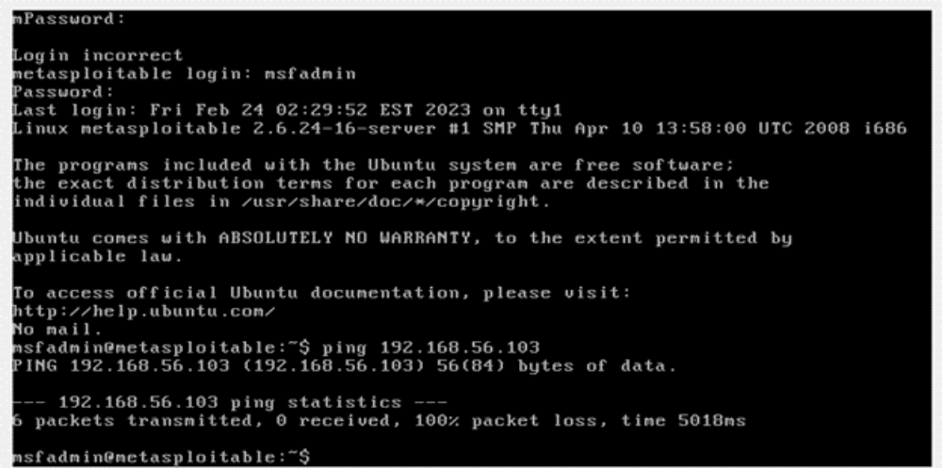
Step 7: The entered username and password in Windows 7 will be now visible at Kali-Linux. By this successful sniffing between Windows7 and Metasploitable machines done using Ettercap tool.
